**Going digital**

**Digitalization and the American workplace**

Mark Muro, Sifan Liu, Siddharth Kulkarni

In recent decades, wave after wave of digital innovation has ensured that “digitalization”—the diffusion of digital technology into nearly every business, workplace, and pocket—has been remaking the U.S. economy and the world of work.

So rapid are the developments, in fact, that while the “digitalization of everything” has become a hallmark of tech’s promise of individual and business empowerment so has it begun to prompt a nagging current of anxiety, including among workers who worry about their future in a world of brilliant machines

And yet, for all of the evidence that big changes are underway, surprisingly little data exist to track the spread of digital adoption across industries and into local workplaces and labor markets. In the absence of such information, the digitalization trend, as prominent as it is, remains diffuse and hard to pin down.

Hence this report: Designed to help address the shortage of data on the topic, the present assessment provides a detailed analysis of changes in the digital content of 545 occupations covering 90 percent of the U.S. workforce in all industries since 2001.

To set the context, the assessment first reviews how the growing power and reach of digital technologies has been reinventing work through the power of computing and IT to speed calculations, accelerate routine work, facilitate sharing, and improve scaling.

Figure 1. Worldwide digital device penetration, 1980 - 2015

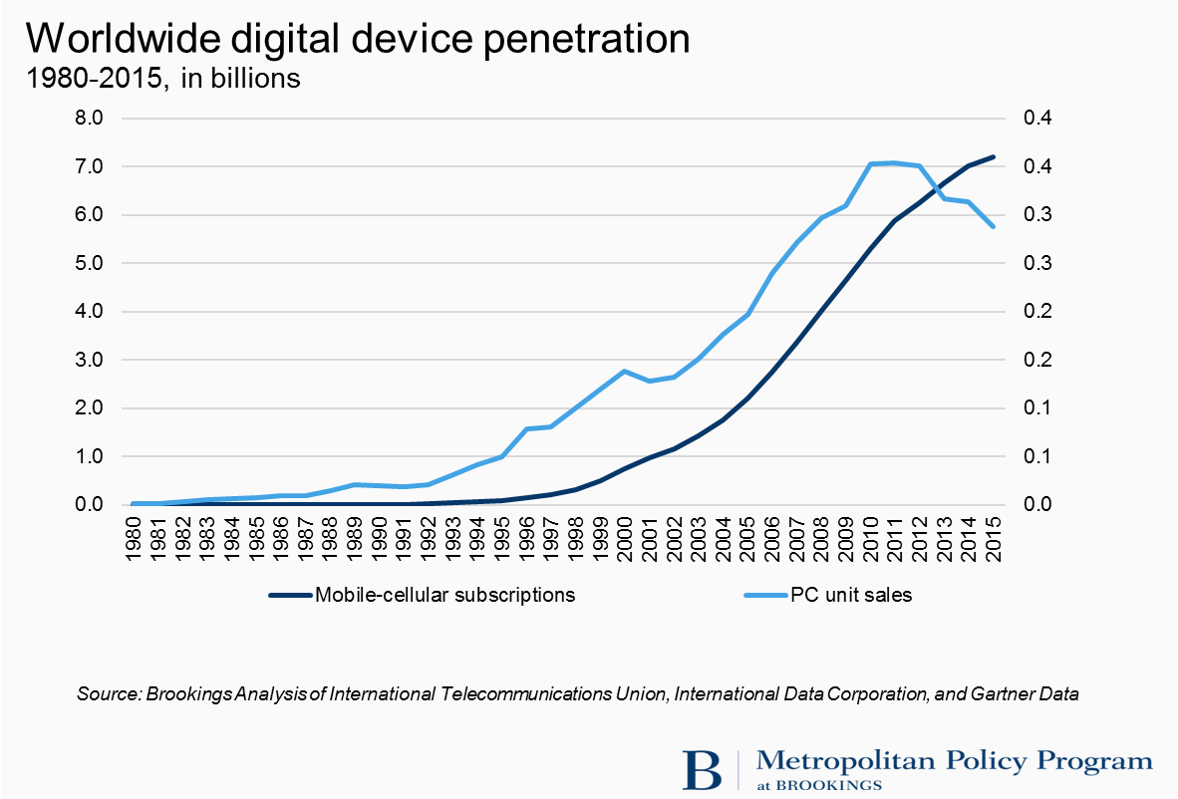

In this vein, the report suggests that the basic conduct of work is being transformed by the continuing integration of digital tools ranging from the Windows and mobile computing to cloud-based enterprise management platforms like PeopleSoft and social and collaboration tools like Slack and Skype. In short, workers of every stripe—from corporate finance officers to sales people to machine operators to utility workers and nurses and Uber drivers—are spending sizable portions of their workdays running the Waze app to navigate traffic; connecting to the office by text message; managing processes through Salesforce; or running diagnostic software at the building site or at bedside.

With those changes in mind, the analysis here then employs the detailed, occupation-specific survey information of the Department of Labor’s Occupational Information Network (O*NET) database to track the changing digital content of hundreds of occupations. To that end, Brookings leveraged O*NET’s “computer-knowledge” and “computer-importance” scores for occupations to create a 100-point tiered rating of hundreds of jobs’ changing computer content.

Table 1. Representative digital occupations and their digitalization levels



As shown nearby, occupations with digital scores of 60 and above are deemed highly digital in our ranking; occupations scored between 33 and 60 are viewed as medium-digital jobs; and occupations scored below 33 require minimal digital knowledge or work.

In this fashion, analysis of the task content of hundreds of U.S. jobs yields a series of findings about the speed and extent of digitalization over the last 15 years:

1. **The U.S. economy is digitalizing at an extremely rapid pace.**

The first takeaway from the analysis is that between 2002 to 2016 the shares of U.S. jobs and employment that require substantial digital knowledge rose rapidly, whether because of changes in the digital content of existing occupations (the largest effect, by far) or thanks to shifts in the distribution of occupations.

Figure 1. Employment by level of job digitalization, 2002 and 2016

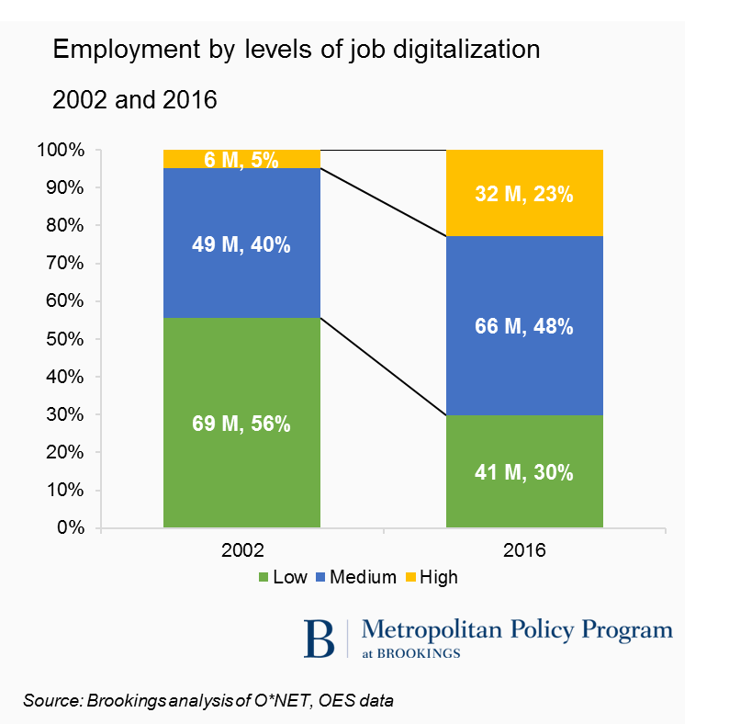

The changes have been striking. Since 2010, nearly 4 million of the nation’s 13 million new jobs created—30 percent of them—have required high-level digital skills. Nearly two-thirds of new jobs required either high- or medium-level digital skills.

1. **The degree and pace of change of digitalization varies widely among occupations and across industries.**

Looking broadly across the job rolls, digitalization scores rose in 517 of 545 analyzed occupations from 2002 to 2016. The average digitalization score across all occupations rose from 29 in 2002 to 46 in 2016, a 57 percent increase.

Overall, the most significant computerization occurred around the lower and middle tiers of the scale where the digital scores of many large and accessible occupations underwent radical increases as basic tech was introduced in low-tech industries.

Digital scores rose 50 percent or more across dozens of mid-digital occupations such as automotive service technicians (39 to 55), registered nurses (38 to 55), and human resources specialists (37 to 60). Likewise, the scores of many lower-score occupations, including home health aides (score rise from 3 to 23), welders (3 to 23), and heavy truck drivers (7 to 30), saw their scores triple or more

Table 2. Selected occupations by 2016 digital score



Add these trends up for industries, and it becomes clear that the entire U.S. economy is digitalizing rapidly but unevenly.

Virtually all industry groups saw their mean digital scores increase between 2002 and 2016, but the level and speed of digital adoption vary significantly, suggesting wide variation in industries’ and firms’ ability to improve their operations, productivity, and results.

Table 3. Industry mean digitalization scores and change, 2002 and 2016



1. **Digitalization is associated with increased pay and job resiliency in the face of automation but also “U-shaped” job creation patterns.**

Digitalization is a key pathway to increased earnings. All across the skills continuum employees are rewarded for the depth and breadth of their digital skills through increased wages. Workers in occupations with medium or high digital skills in 2016 were paid significantly more than those in low-digital occupations.

Figure 2. Mean annual wage by digitalization level, 2016

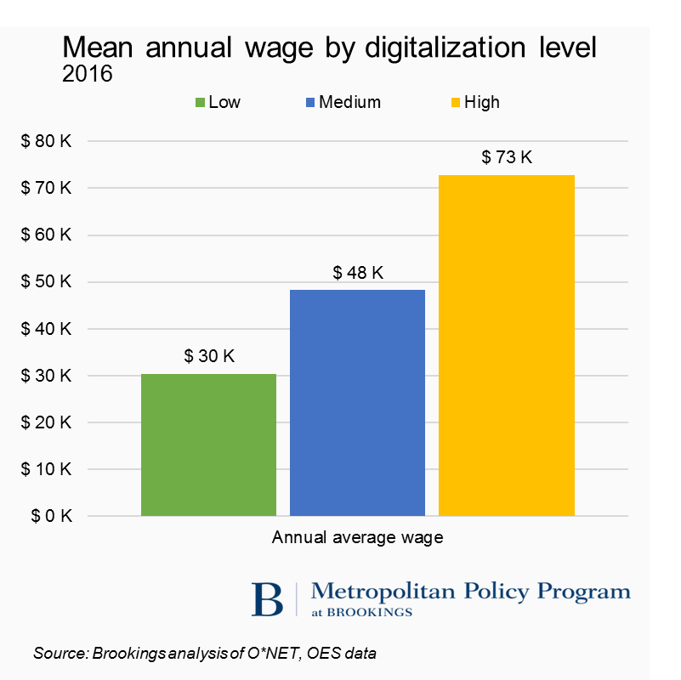

These pay differentials are important not just for their influence on worker compensation but also because they point to the durability of work in the era of automation. To explore this, we compared occupations’ digital scores to their automation potential, as quantified by the McKinsey Global Institute’s estimates of the share of an occupation's overall task content that could be automated by adapting currently demonstrated technology.[1] These comparisons revealed a modestly strong negative correlation between an occupation’s increased digital content and the share of its tasks vulnerable to automation.

Figure 3. Average automation potential of major occupational groups by mean digital score

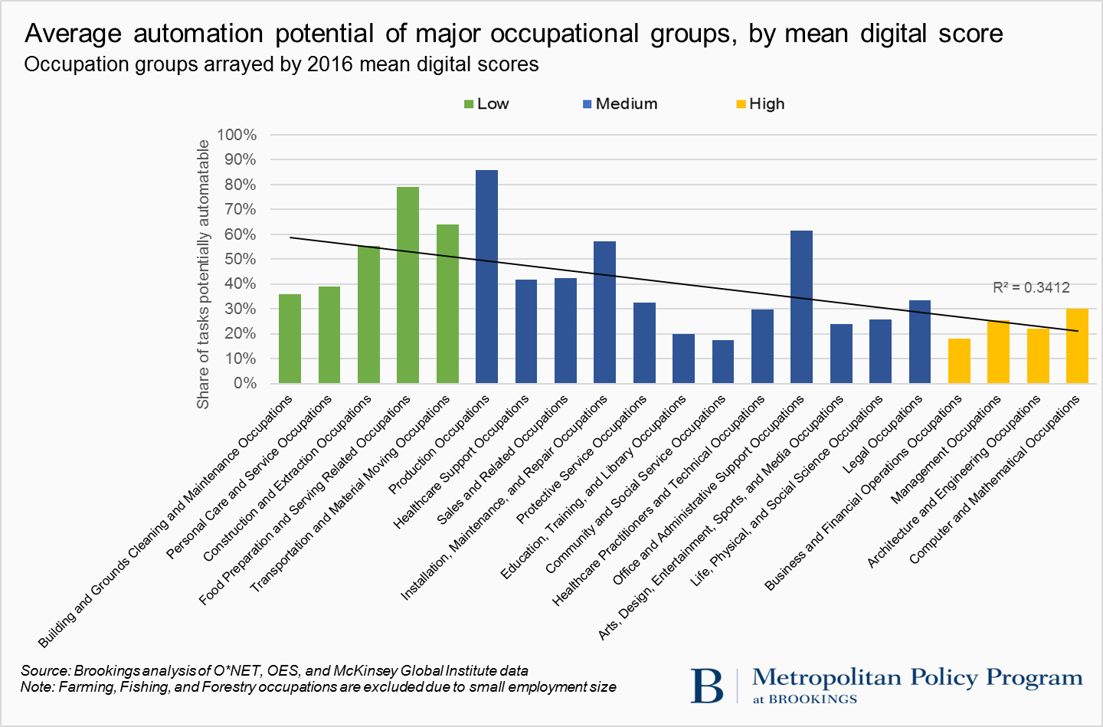

Similar trends surface with regard to digitalization and wage growth. For the most part occupational groups with higher digital skills are seeing faster wage growth.

Figure 4. CAGR of real mean annual wage by occupation group, 2010 – 2016

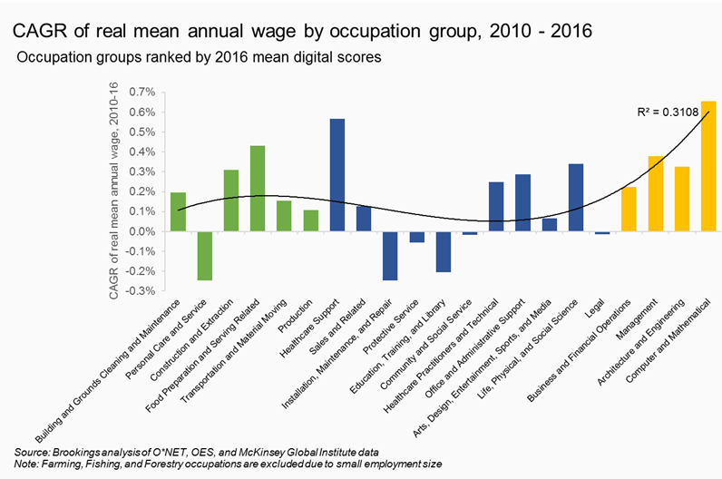

Focusing on patterns of job creation, finally, the digitalization of the U.S. economy appears to be contributing to the hollowing out and polarization of employment and wage distributions noted by David Autor and colleagues.[2]

Figure 5. CAGR of employment by occupation group, 2010 – 2016

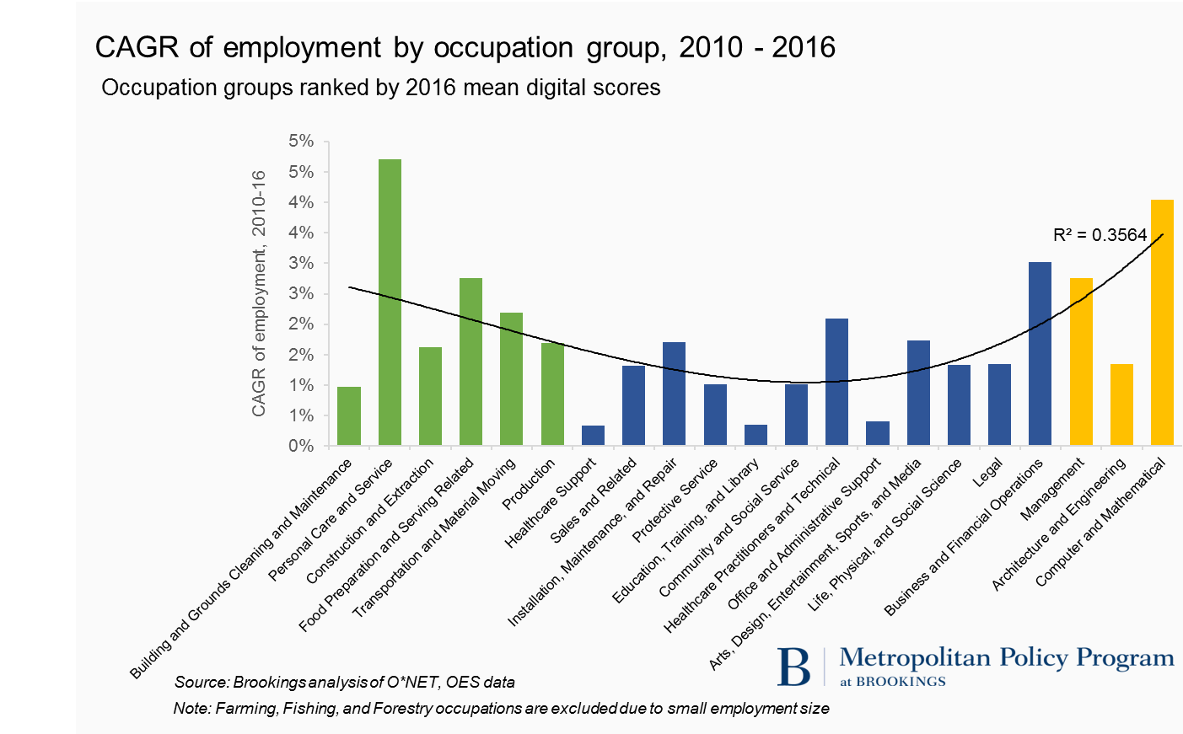

These occupational patterns, meanwhile, are also contributing to parallel patterns of industry performance. For the most part, industries output, productivity, and wage growth tends to reflect industry-level digitalization levels.

In this regard, digitalization appears to be contributing to: job creation and pay gains in high-digital industries; slow job creation and modest pay gains in medium-digital occupational groups (except in personal-services like health care, where the growth has been faster); and faster job growth but low and slow-growing wages in low-digital personal service occupations.

1. **The extent of digitalization also varies widely across places and is strongly associated with variations in regional economic performance.**

In geographical terms, digitalization is happening everywhere, but its progress varies widely across the map. Just as the diffusion of digital technology and processes has been uneven across occupations and industries, it is proceeding unevenly across space.

For example, states’ mean 2016 digitalization scores vary noticeably, and range from 51 in the **District of Columbia** to 41 in **Nevada**.

Figure 6. Mean digital score by state, 2016

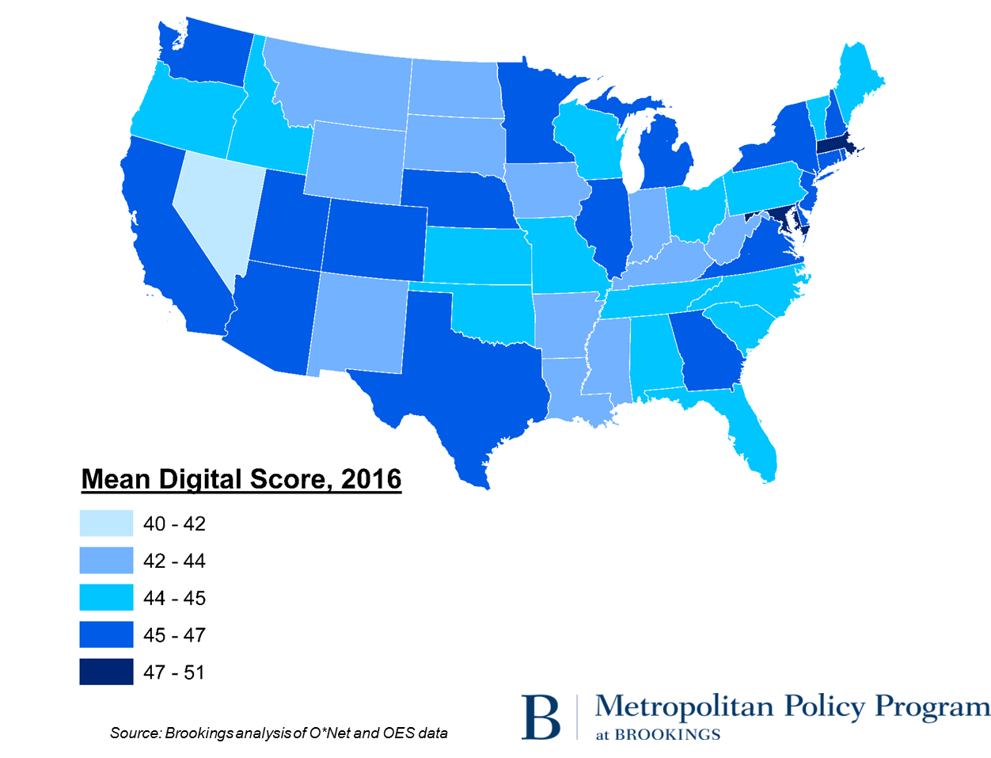

Not surprisingly, the states’ digital scores strongly predict their median wages.

Figure 7. Correlation between states’ mean annual wage and mean digital scores, 2016

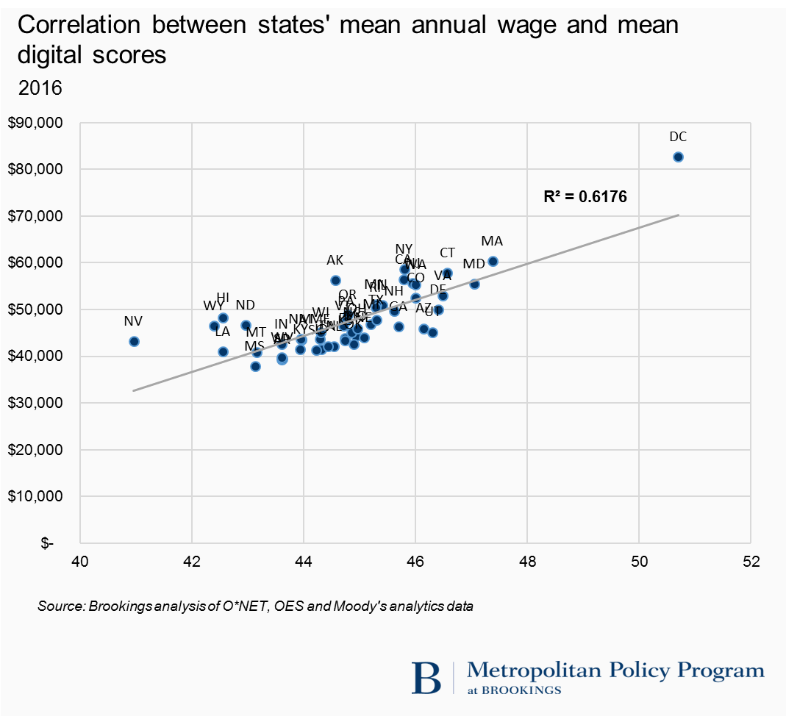

The data for metropolitan areas, meanwhile, reveals more variation. Large-metro mean digitalization scores for 2016 range from 47 in **San Jose**, Calif. to 36 in **Las Vegas**. Following San Jose at the top of the digitalization rankings comes a “who’s who” of higher-tech advanced industry centers ranging from **Boston**; **Austin**, Texas; **Hartford**, Conn.; **Salt Lake City**; **Raleigh**, N.C.; **Seattle**; **San Francisco**; and **Madison**, Wis.—all with mean 2016 digitalization scores above 43.

Figure 8. Mean digital score and share of high digital jobs by metropolitan area, 2016

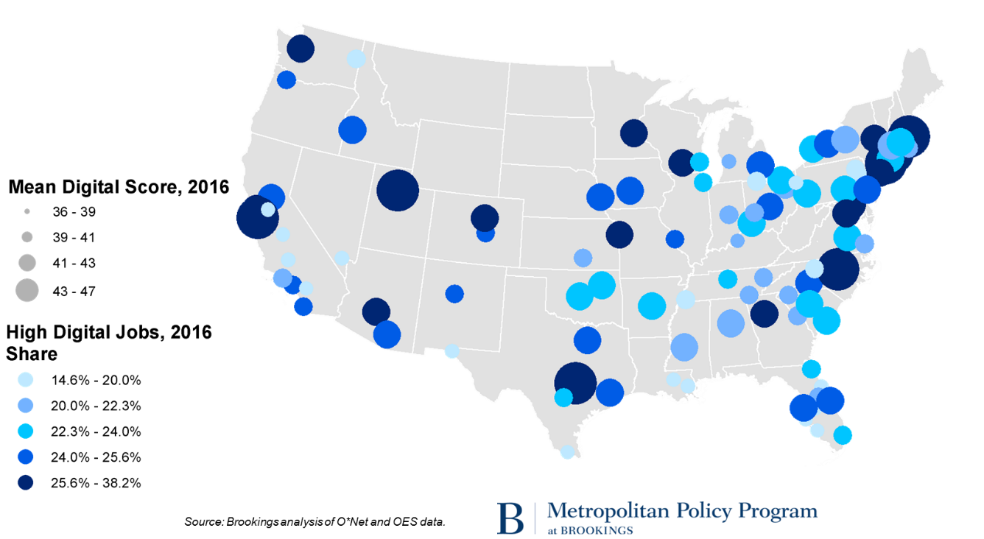

All of these more digital metros saw their mean digitalization score increase by 12 to 18 points, though *all* metros saw significant score increases to the point that large cities’ mean digitalization scores have been converging. The left panel of Figure 9 shows that metros with lower mean digital scores have actually been increasing their digital ratings faster than metros with higher scores.

Figure 9. Convergence and divergence among large metros by mean digital score and high digital share, 2002 – 2016

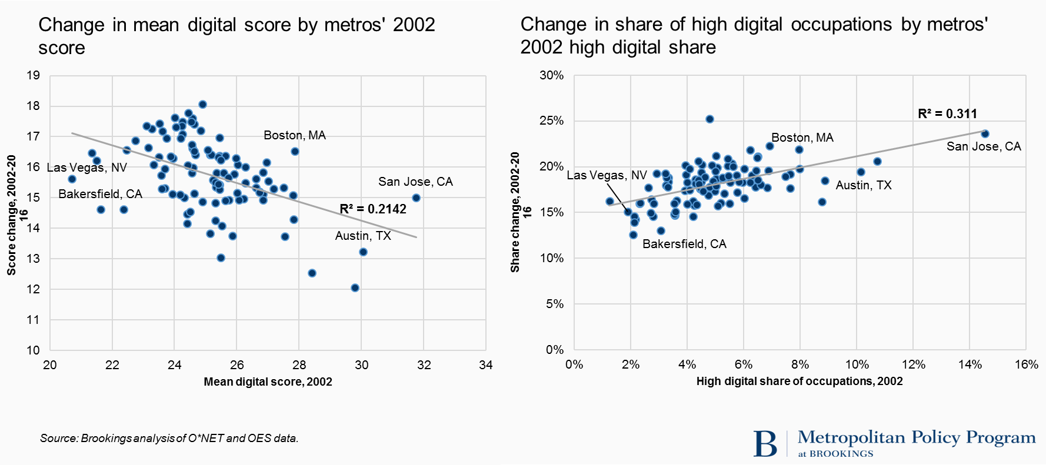

The story is different, however, when mapped for metros’ varying shares of employment in high-digital occupations. Not only do metros’ high-skill digitalization ratings vary sharply; they are also diverging. In this regard, the digital rich are getting richer, a trend that can be seen in the 100-metro scatterplot in the right panel of Figure 9. The higher a metro area’s 2002 share of highly digital occupations, the greater the growth of its share of jobs in such occupations in the years 2002 to 2016.

As to the implications of these variations for regional economies, they follow directly from the strong correlation of digitalization with worker compensation and industry performance.

Figure 10. Correlation between metros’ mean annual wage and mean digital scores, 2016

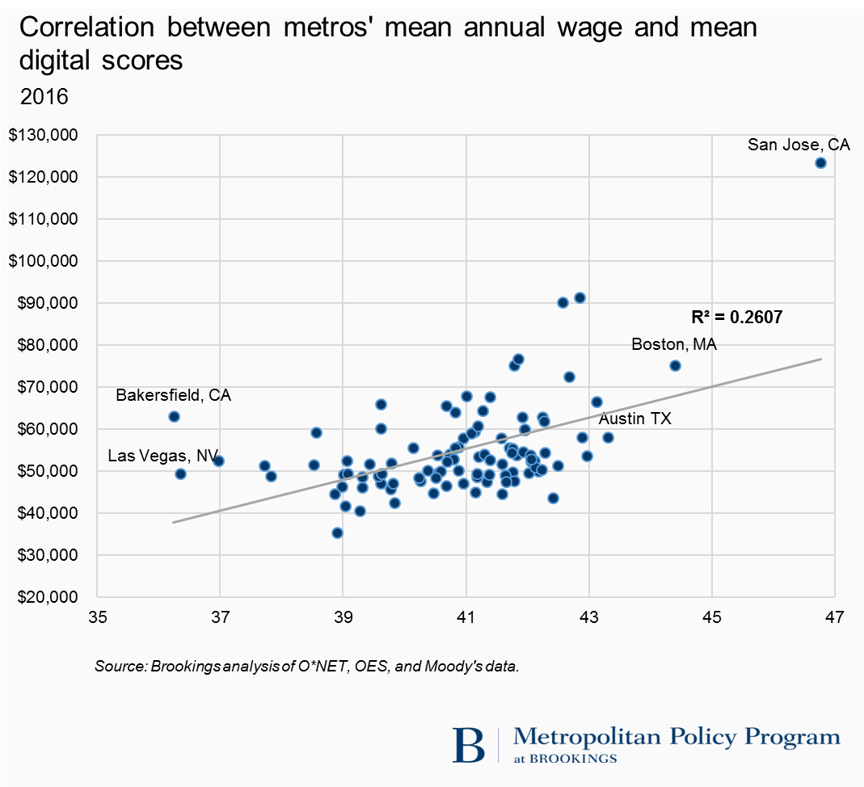

These trends underscore a key point about the influence of digitalization on regional prosperity: variations in the digital skills of the local workforce may be contributing to the polarization of cities’ economic fortunes. Digitalization, in that vein, appears at once to reflect and reinforce the polarization of workforce skills across places that is improving pay for many people and places while widening the divide between the leading cities and the laggards.

1. **Digitalization is changing the skills workers need to access economic opportunity while creating new race- and gender-based training challenges.**

Digitalization, finally, is changing the skills less advantaged workers need to secure good jobs. Given that, the spread of digital tools is underscoring the importance of digital competencies in helping less-educated workers secure basic opportunity even as it throws into relief sharp disparities among particular groups’ digital preparedness.

To see this, it is worth looking at changes in the nature of what have been called by turns “good jobs” or “middle-skill” jobs—jobs that have the potential to help workers without a four-year college degree earn enough to support themselves and begin to move toward the middle class.[3]

Table 4. Share of jobs by digital score, 2002 and 2016



That the pace of digitalization remains rapid suggests that millions of workers could be shut out of decent middle-skill opportunities if they lack the requisite skills.

And here is another issue: The mean skills ratings of the jobs occupied by workers in major demographic groups vary in ways that almost certainly contribute to those groups’ uneven access to opportunity.

Figure 11. Average digital scores by demographic group, 2002 and 2016

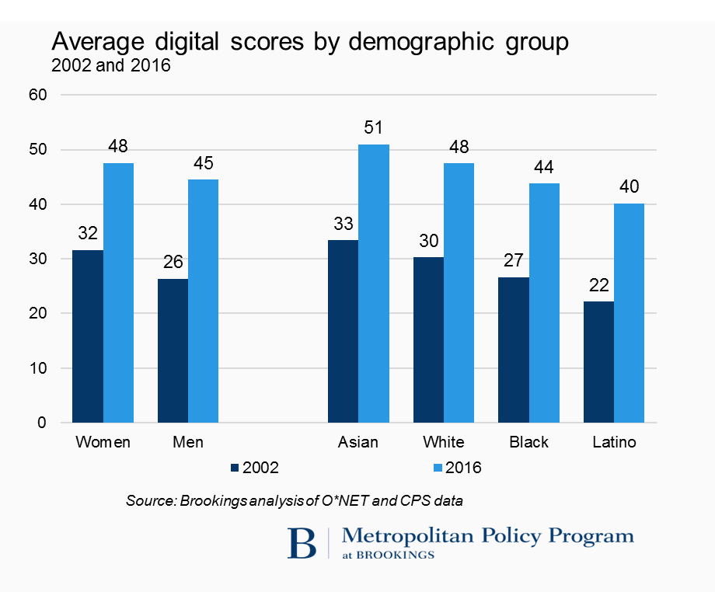

Women, with slightly higher aggregate scores as a group than men, dominate employment in many of the largest medium-digital occupational groups, such as in health professions, but by contrast, remain significantly underrepresented in such highly digital positions as computer and mathematical occupations and engineering.

Equally sharp variation characterizes the employment profiles of the nation’s racial and ethnic groups.

Table 5. Over- and under-representation of gender and racial groups by occupation group, 2016



While digitalization holds out significant opportunities for less-educated or historically marginalized workers or groups to move up the employment ladder, too few of them as yet appear to attaining that progress.

**\***

Digitalization, in sum, is transforming the world of work. Workers, firms, and industries as well as entire regional labor markets are all being dramatically affected. As such, the spread of digitalization underscores the need for new, widespread, and more creative initiatives to improve workers,’ firms,’ and regions’ access to relevant digital and related “soft” skills.

To this end, then, two distinct priorities (and one cross-cutting vision) appear urgent. First, firms, industry associations, educational institutions, and governments must work urgently with workers and students to **expand the high-skill IT talent pipeline**. And second, governments, businesses, and others need to greatly **expand basic digital literacy, especially among underrepresented groups**.

To the first priority agenda, the onrushing spread of demand for tech workers in dozens of large “tech-using” industries ranging from health and education to professional services means that cities and businesses will likely experience even sharper demand than they do now for skilled digital workers. They will need to invest urgently in smart competency- and work-based training solutions.

To the second end priority, the data here underscore that when it comes to the nation’s broader economic health the larger impact on U.S. prosperity may come from efforts to expose large numbers of less-educated workers to the basics of “everyday” software—spreadsheets and word processing, programs for medical billing and enterprise management. Such efforts are also urgent as even the most accessible decent jobs see their digital content soar.

Otherwise, on both fronts, an effort must be made to **cultivate durable human qualities**, not just rote skills better done by machines.

In this regard, humans—even while learning to work better with computers, whether in the higher-end IT pipeline or in the world of everyday software—need to think much more seriously about what they can do that computers can’t. Computing will soon be virtually everywhere, which prompts jitters, yet that amounts to an incredible opportunity. People will be freed up to give the rote work to the machines and use their uniquely human qualities to solve pressing problems and lead unimagined advances. People of all walks of life should get started with that.

1. 1 Brookings is grateful to Michael Chui of the McKinsey Global Institute for sharing data here. For more on McKinsey’s automation analyses see James Manyika and others, “A Future That Works: Automation, Employment, and Productivity” (San Francisco: McKinsey Global Institute, 2017).
2. See, for example, David Autor and others, “The Polarization of the U.S. Labor Market,” (2006) as well as Autor and Dorn, “The Growth of Low-Skill Service Jobs and the Polarization of the U.S. Labor Market,” (2013).
3. Richard Shearer and his colleagues at the Brookings Institution define and analyze good jobs in one metropolitan area in Richard Shearer and others, “Opportunity Clusters: Identifying Pathways to Good Jobs in Metro New Orleans” (Washington: Brookings Institution, 2015). They employ three groups of criteria to identify good jobs that are attainable for workers without a four-year degree, provide full-time employment and benefits, and offer pathways to living wages and financial security. Burning Glass Technologies, the U.S. Competitiveness Project at Harvard Business School, and Accenture have developed definitions of “middle-skill jobs” that require more than a high school education but less than a bachelor’s degree while paying more than the national living wage. See, for example, U.S. Competitiveness Project, Burning Glass, and Accenture, “Bridge the Gap: Rebuilding America’s Middle Skills” (Boston: Harvard Business School, 2014) and Burning Glass, “Crunched by the Numbers: The Digital Skills Gap in the Workforce” (Cambridge, Mass., 2015).